CPE 4800 - Senior Design Proposal, Fall 2025

Concept Proposal Document

Half-Byte Solutions

Electrical and Computer Engineering
Kennesaw State University
Faculty: Dr. Jeffrey L Yiin
October 10, 2025

- Team Formation
Our team name is Half-Byte Solutions. Our mission is to provide disabled individuals with accessible, independent, and private communication. The project manager is Julia Johnson. The other members of our team are Giancarlos Hernandez, Jalen ToOur team has decided to divide work up evenly as we progress through the project, and will not be utilizing other roles.

- Ideas
The first idea we had was a smart plant/crop monitoring system. This product would be mainly used by farmers, gardeners, and homeowners with an interest in raising plants. The main problem is that people often forget to water their plants and also might overwater or underwater their plants, which might lead to their plants dying. Also, beginners in raising plants can often struggle in figuring out their specific plants’ needs, especially if they have multiple different types of plants. The solution to this problem would be a smart pot that would track soil moisture, temperature, and light exposure using different sensors. It would use the data collected to monitor a plant's health and needs.

If the device detects that the plant needs something, it will alert the user with what the plant needs. The smart plant pot would also be connected to a dashboard where the user can also monitor the plants/crops. The secret sauce of this product is that it can prevent issues with the plants a user is raising before they occur by tracking and logging the status of different conditions a plant needs. Also, this device doesn’t just measure soil moisture, but temperature, light conditions and plant size as well, which can be used to give unique care feedback based on each unique plant and the plants’ surroundings.
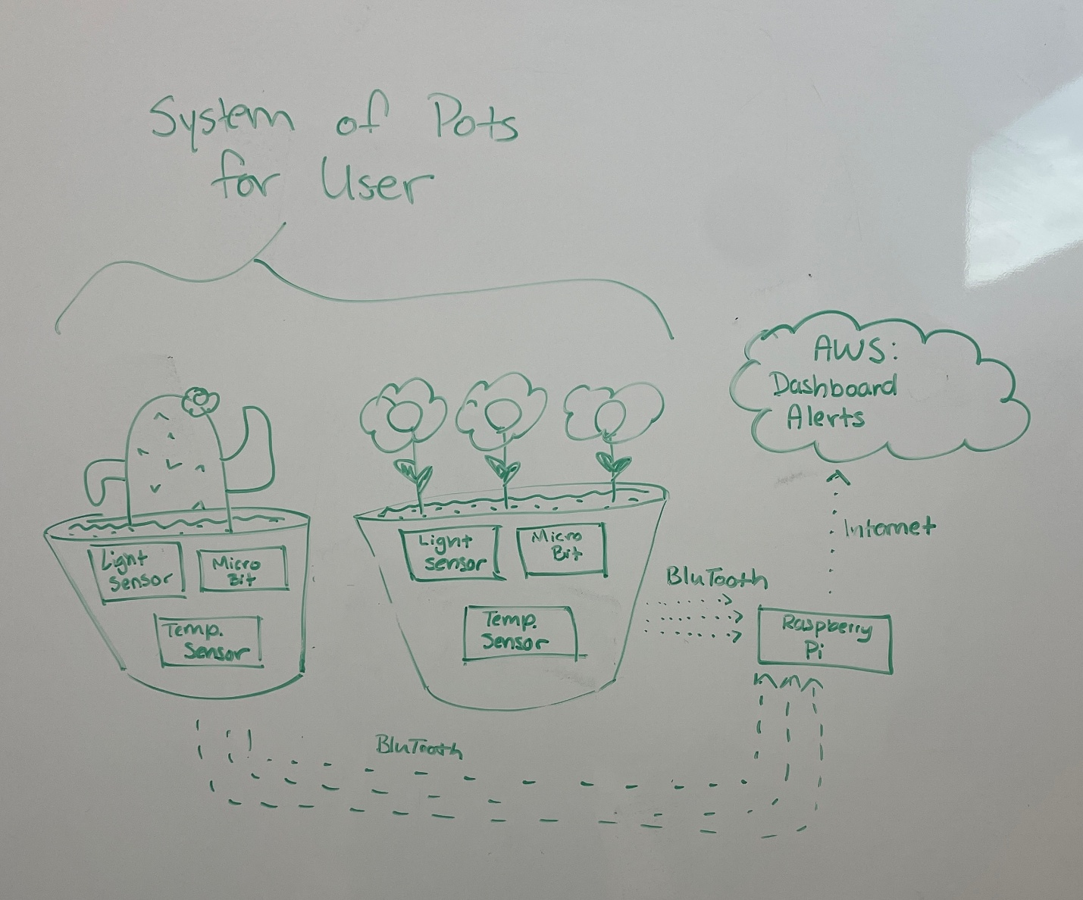

The second idea we had was FlexType Electromyography (EMG) Keyboard. This Keyboard would mainly be used by individuals with neurological or visual impairments. These individuals often struggle with typing on traditional keyboards and often require assistance with typing due to limited hand and arm mobility as well as difficulty seeing the keyboard. The solution to this problem would be an EMG wearable device that would detect the electrical signals in your arm muscles when moving your hands and fingers to create different gestures.

The device will have an AI model that will be trained to recognize around 8 – 10 gestures. Each of these gestures will correspond to a different set of letters. For example, Gesture 1 would correspond to the set of letters: a, b, c and d. Once the user has finished typing his word, the output from this device will get sent to a word prediction model where it will guess which word the user is trying to type based on the context of the message they are typing. If the model predicts the incorrect word, the user can tell it to go to the next most likely word until it gets the correct word. The secret sauce of this product is that it can be used in many different environments like loud areas or places where the user needs to be quiet. Also, this product allows the user to send their messages confidentially when compared to other alternative keyboards like Voice-to-Text.
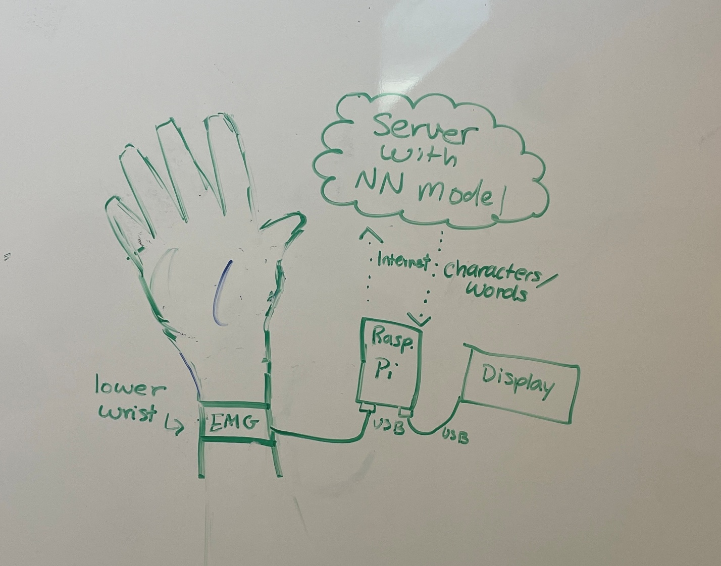

- Concept Validation
Our chosen concept is the FlexType EMG keyboard. Our product is the designed to give disabled users the freedom to type. Unlike other alternative keyboards, like Voice-to-Text, our product would be discrete, portable, and accessible to people of all kinds. Our product will give disabled users their independence and ability to type back.
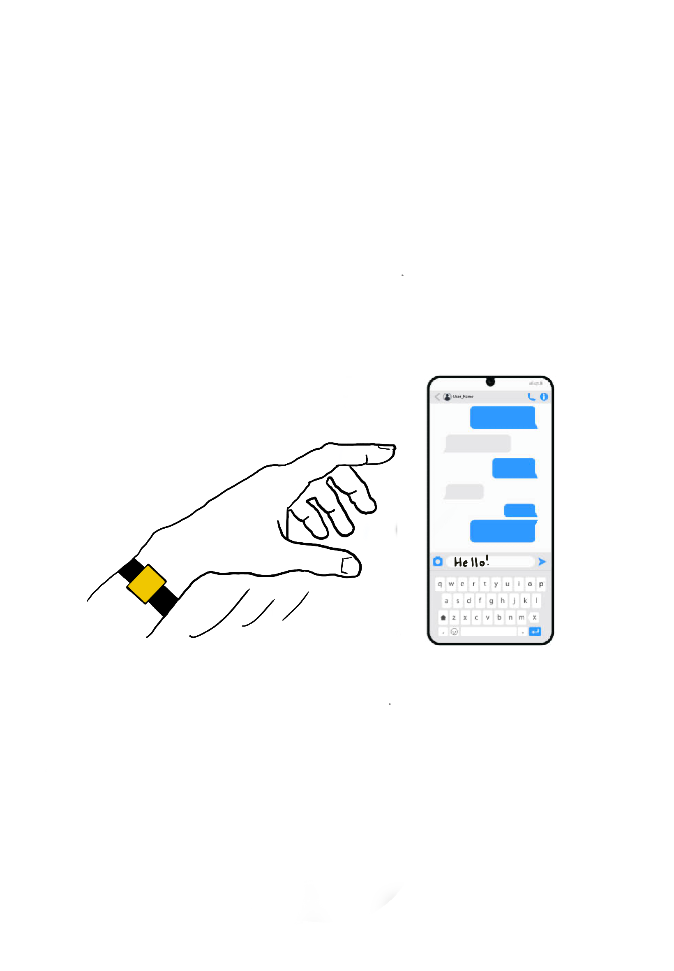
Our customer graphic is disabled individuals without fine motor control in their fingers and hands. Our product also extends to visually impaired individuals who can’t see the keyboard while typing. While many of these customers would be elderly (~70 million in the U.S.), we would be targeting individuals of all ages. Our key demographic would be anyone without fine motor control in their fingers and hands, or anyone unable to type on their own due to tremors, missing fingers, etc. (~2 million in the U.S.).
For our customer surveys, we developed two scripts. One script is for disabled customers, and the other is for caretakers and healthcare workers that have experience working with disabled customers.

Interview Questions (For Disabled Users):
- What is your experience typing on traditional computer and mobile keyboards?
- What alternative to traditional keyboards do you use, if any?
- Have you ever asked anybody for help with typing-related tasks, ex. sending a text?
- What qualities do you look for in keyboards?
- What types of hand/ wrist/ arm movement are easiest for you? Hardest?
- What struggles do you have when operating traditional keyboards?
- What struggles do you have when operating alternative keyboards, ex. Voice to text?

Interview Questions (For Caretakers/ Healthcare Workers):
- What is your experience helping patients type on traditional computers and mobile keyboards?
- What alternative to traditional keyboards do you usually recommend, if any?
- Have you ever been tasked with performing typing related tasks for patients?
- What qualities of traditional keyboards are hurtful for disabled patients?
- What types of hand/ wrist/ arm movement are easiest for disabled people? Hardest?
- What struggles do you see your patients encounter when they operate traditional keyboards?
- What struggles do you see your patients encounter when they operate alternative keyboards?

Our customer base faces many everyday problems when it comes to typing. Based on our interviews, the top three problems users are facing are difficulty pressing the right keys, difficulty with double-clicking letters or keys, and issues with accuracy when using Voice-to-Text. Our product solves all three of these problems by removing the keys and voice aspect all together. Users will not need to use precise movements or take precautions with their environment when typing messages.
Our top feedback was about how difficult it is to press keys, and how many users wished the keys were larger or less sensitive when holding down or tapping them multiple times. Our takeaway on this is that on mobile devices, it is very difficult to make keys bigger without having to scroll to the side, which could introduce more issues for this customer base. Because keys are the main source of the problem, we intend on removing them from the equation all together.

One interesting comment we got was about keyboard switching, specifically between the letters and symbols keyboards. This was interesting because it is another factor that we had not yet taken into consideration. If someone wants to add a dollar sign or quotes, for example, it is difficult to change the keyboard, select the symbol, then change the keyboard back to the alphabet. Our group had not planned on unique symbols, but thanks to this comment, we can know that that point into consideration during development.

- Market Analysis and Competitive Landscape
Our FlexType sits between two markets of vastly different sizes, the gesture recognition market valued at $25.4 billion, and the wearable EMG market valued in the low hundreds of millions USD. This indicates that our product potentially has a very good revenue upside when it comes to long-term growth. However, as of the present time we will be a very niche product.
Some existing competitors would be VR/AR or wearables that use finger tapping to control device/UI, and our main competitor would be Meta with their EMG gesture wristband. For existing tap typing or tap control devices, their main advantage against us is that there is already a market and products out there. However, for our intended purpose those devices have their weaknesses, including requiring precise finger taps, less suitable for people who don’t have fine motor control, and they are not made with accessibility in mind.
Whereas for Meta’s EMG wristband, their biggest advantage is their big budget and access to their massive ML/AL models. As for the weaknesses when compared to FlexType, Meta will most likely prioritize mainstream use cases like AR/VR before accessibility niches such as FlexType. With FlexType we will be able to gain clinical partnerships easier, have in house user tests, and can prioritize features dedicated to our disabled users.

- Concluding Remarks
We learned that a technically brilliant idea is not enough; it must solve a validated and acute problem for a specific group of people. At the start, we had concepts that we had to decide on, but we eventually stumbled upon the pain points for individuals with typing difficulties. This shifted our focus from “entertaining gadgets” to tools that allow the user to have autonomy.
While our survey scripts provided a framework, some of our most valuable insights came from unprompted comments, such as the difficulty of switching between symbol and letter keyboards. This taught us to listen actively for hidden pain points and unexpected use cases that can significantly shape a product's feature set for the better.
We believe the FlexType EMG Keyboard can make a profound difference because it directly addresses an issue that concerns independence, privacy, and accessibility.
Unlike traditional keyboards that require some type of fine motor skills or voice to text that takes away the users ability to be discrete, FlexType redefines the input method itself. It empowers the user to leverage the motor gestures that they can control and allows them to have private text.
The structured approach to concept validation, forcing us to get out the building and test our hypotheses and our assumptions proved to be a valuable experience for us all. If we were to offer a piece of advice, we would suggest workshops that demonstrates how to effectively and sensitively interview people, especially if they belong to such vulnerable communities. Overall the framework has been genuinely helpful and we feel well-equipped to move on to the next phase of the project.

